Biopsychosocial Model of Health
Engel (1977) challenged the traditional biomedical health care model. He shared that many physicians base their care on this model in the Western World. Engel shared that the patient is a complex entity and that physicians using the biomedical model were missing important elements. The traditional model was based on the conceptual task-focused role of physician services capitalizing on the identifying the disease and the treatment. Engel identified the missing elements and developed the biopsychosocial model of health care. This model is system-based on the concept of the person as a cell, which is part of the organ, which is part of the person, family, community, culture, subculture, society, nation and biosphere. The biopsychosocial model basis is that the other parts of the system influence the entire entity and health
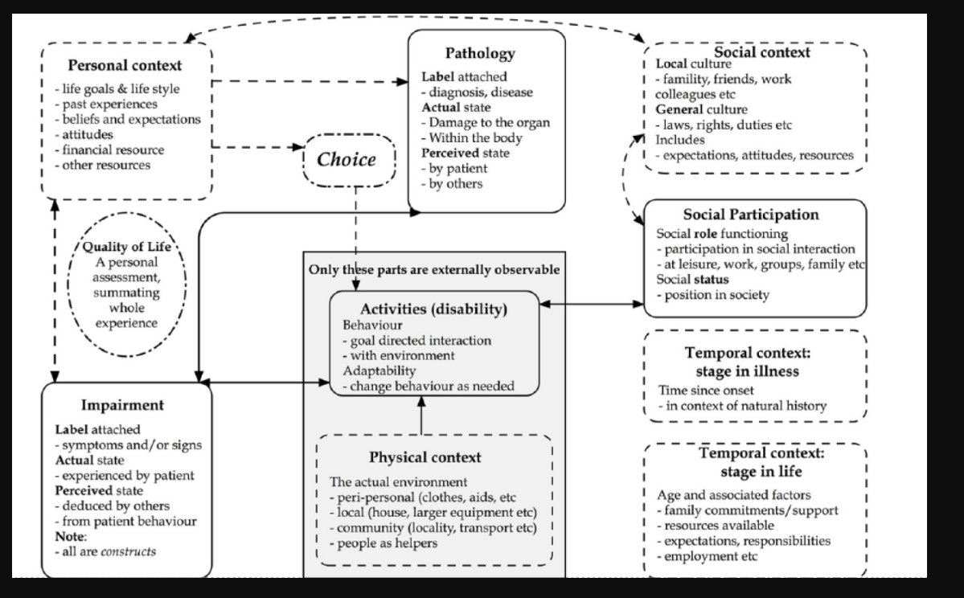
Wade (2017) figure illustrate the complexities of a holistic, biopsychosocial model of illness with components of importance. In this context, the person is multi-dimensional, has complex influences, and hopefully will continue to evolve. The pathology of illness or disease is part of patient’s social context, social participation and leads to behavioral goals that are impactful on the patient journey and quality of life. The biopsychosocial model of health applies to oncology and my patient population and is relevant to my practice. Oncological disease begins at the cellular level and affects organ(s) of the body. Our oncological drugs used to fight against cancer function by killing cancer cells directly at DNA synthesis in the cell cycle or at a biological level of binding to receptors and inhibiting function. Cancer.org. Health related quality of life as a key role correlates to cancer during chemotherapy treatment. Lauriola (2019). They found an association of physical functioning and mental health. The biopsychosocial model in this study integrates social elements of support with a fighting spirit, and positive thinking. There were significant relations between mental health, physical functioning and hopelessness, helplessness, cognitive avoidance (this is not happening to me) and anxious preoccupation. The maladaptive qualities of helplessness can be off set through the supportive care of family and friends. The patient can and will do better in a positive mental environment for chemotherapy patients to cope with the burden of disease and treatment. Lauriola (2019) biopsychosocial model applied to oncology patients requires them to have significant others and social networks for adjustment to their cancer journey. These elements are essential for the patient’s emotional adaptation to maintain a positive fighting spirit in response to physical illness.
References
Engel, G. L. (1977). The need for a new medical model: a challenge for biomedicine.
Science (New York, N.Y.), 196(4286), 129–136. https://doi.org/10.1126/science.847460
Wade, D. T., &amp; Halligan, P. W. (2017). The biopsychosocial model of illness: a model
whose time has come. Clinical Rehabilitation, 31(8), 995–1004.
https://doi.org/10.1177/0269215517709890
How does chemo work? (n.d.). Cancer.org. Retrieved October 18, 2024, from
https://www.cancer.org/cancer/managing-cancer/treatment-types/chemotherapy/
how-chemotherapy-drugs-work.html
Lauriola, M. &amp; Tomaj M. (2019) Biopsychosocial Correlates of Adjustment to Cancer
during Chemotherapy: The Key Role of Health-Related Quality of Life.,
from https//pmc.ncbi.nlm.nih.gov/article/PMC6431483/
\

